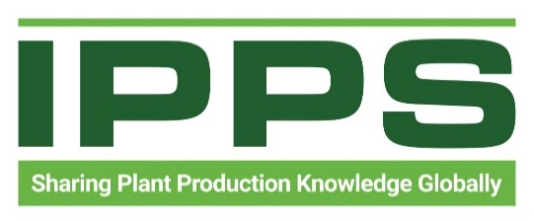
IPPS Announces Organizational Rebrand, New Website, and 2026 International Membership Drive

November 2025
The International Plant Production Society (IPPS), a global network founded in 1951, is proud to announce a major organizational rebrand. Formerly known as The International Plant Propagators’ Society, members voted for the name change to better reflect the diverse and evolving green industry.
Since its founding more than 70 years ago, IPPS has grown from a small group of propagation specialists into a worldwide community spanning seven regions: Australia, Eastern Region North America, Europe, New Zealand, Southern Africa, Southern Region North America, and Western Region North America. Today, members represent every sector of plant production including nursery and greenhouse growers, propagators, breeders, educators, researchers, public garden professionals, and allied industries.
“Our membership now reflects the full spectrum of plant production, well beyond our propagation roots,” said Tom Saunders chair of IPPS International. “This rebrand honors our history while embracing the breadth of expertise found across our regions globally.”

A New Website for a New Era
Along with the rebrand, IPPS has launched a new and improved international website designed to strengthen communication and streamline access to resources across all regions. The upgraded platform provides clearer pathways to educational materials, event details, proceedings, regional contacts, and student and early-career opportunities.
Key features include:
- Modern, intuitive navigation
- Enhanced access to research, proceedings, and technical resources
- Updated regional pages and membership information
- New tools for outreach, communications, and professional development

2026 International Membership Drive
To celebrate this new chapter, IPPS will kick off a global membership drive in 2026. Each of the regions will participate in coordinated outreach efforts, focusing on welcoming new professionals and reconnecting with individuals who may have stepped away from the organization.
“The green industry continues to diversify and IPPS is evolving with it,” said Brie Arthur International Delegate representing the Southern Region North America. “Our goal is to ensure IPPS remains the strongest professional development community for plant producers worldwide.”

Honoring the Past, Investing in the Future
Though the name is changing, the mission remains the same: To Seek and To Share Plant Production Knowledge Globally. For more than seven decades, IPPS has fostered collaboration, practical learning, and lifelong relationships among plant professionals around the world. The new name, International Plant Production Society, reflects what the organization has truly become: a global leader in advancing all aspects of plant production.
IPPS invites members, partners, and industry supporters to join in celebrating this rebrand and the launch of a vibrant new era.
For more information, visit: Home - IPPS International

