
International Plant Production Society
Southern Region North America
2025 Sponsorship Form
International Plant Production Society Southern Region Annual Meeting Sponsorship Invitation
The International Plant Production Society, Southern Region of North America, cordially invites you to sponsor our upcoming annual meeting, scheduled for 19-23 October 2025, at the DoubleTree Orlando at SeaWorld, Orlando, FL.
Event Overview: This highly anticipated event gathers professionals from across the green industry and academia for unparalleled educational programs and tours. Your sponsorship plays a pivotal role in managing costs and ensuring our members access the best opportunities available in horticulture today.
Mission of IPPS
- Sharing knowledge, information, and skills
- Supporting lifelong career achievements
- Enhancing professional recognition
- Advancing research, education, and horticultural integration
Unique Attributes of IPPS:
- Global reach and diverse knowledge base
- Focus on individual membership, fostering personal connections within the industry
- Promoting collaboration among growers, researchers, educators, and industry professionals.
Your Sponsorship Impact: By sponsoring our event, you contribute directly to the success of this significant horticultural gathering. Detailed sponsorship levels and benefits are enclosed for your review.
Next Steps: For more information on the event and sponsorship opportunities, please refer to the enclosed materials. A member of our event planning committee will follow up with you soon to discuss how we can collaborate effectively. We eagerly anticipate your participation in this influential event shaping the future of horticulture in our region.
Best regards,
Richard May Sponsorship Chair Todd Gentry Local Site Chair
(850)539-6495 richard@maynursery.com (352)223-4434 todd.gentry@cherrylake.com
IPPS Southern Region Sponsorship Levels and Opportunities 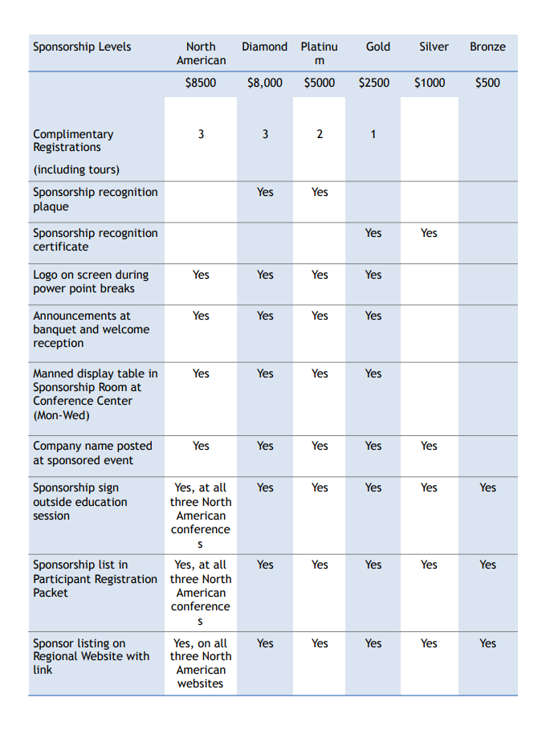
IPPS-SR 2025 Conference Sponsorship Payment Form
Conference Dates: 19-23 October 2025 Orlando, FL

Please make your check payable to:
IPPS- SR International Plant Production Society Southern Region
Mail to: IPPS SR 4661 Crystal Drive Columbia, South Carolina 29206 Federal EIN: 75-2212643
Company Name ______________________________________________________________
Mailing Address ______________________________________________________________
City, State, Zip, _______________________________________________________________
Contact Person _______________________________________________________________
Email _____________________________ Phone ___________________________________
Sponsorship Level:
Diamond $10,000 __________
Platinum $5,000 ___________
Gold $2,500 __________
Silver $1,000 __________
Bronze $500 __________

To Pay by Credit Card:
Card Number ______________________________________________
Expiration date: ____________________
Security code on back of card _______________
Name on card _________________________________________________________________
Signature _____________________________________________________________________
Credit card mailing address and zip code ______________________________________________________________________________
For additional Information contact: Donna Foster (803) 743-4284 scplant@bellsouth.net

